Tutorial 3

Chapter 3

- Discuss any 4 common dimensions of requirements classification.
Functional or Nonfunctional Requirements
Product or Process Requirements
Data Requirements
External Interface Requirements
The Requirement Priority – the higher the priority, the more essential the requirement is for meeting the overall goals of the software. Eg: mandatory, highly desirable, desirable or optional.
The Scope of the Requirements – refers to the extent to which a requirement affects the software and the software component. Requirements of global scope may strongly affect the s/w architecture and the design of many components, whereas requirements of narrow scope may have little impact on the satisfaction of other requirements

- State the 4 types of conceptual models that were discussed in lecture. Briefly discuss the usage and example(s) of each type.
i) Context Models
- Used to illustrate the operational context of a system – they show what lies outside the system boundaries which may include external entities, hardware and other software
- System boundaries are established to define what is inside and what is outside the system
- Eg: Context Diagram of DFD (ie .Level 0 DFD)

ii) Interaction Models
- Modeling user interactions is important to identify user requirements
- Modeling component interaction helps to understand proposed system structure
- Eg: i) Use case diagram in UML, ii) Sequence diagram in UML, iii) DFD

iii) Structural Models
- Display the organization of a system in terms of the components that make up that system and their relationships
- Eg: Class Diagram in UML
- Display the organization of data or entities
- Eg: Entity Relationship Diagram (ERD)

iv) Behavioral Models
- model of the dynamic behavior of a system as it is executing
- Show what happens or what is supposed to happen when a system responds to a stimulus (data or events) from its environment
- Eg: i) State diagram in UML, ii) Sequence diagram in UML
3. Discuss why we should perform requirements allocation?
- It is important to permit detailed analysis of requirements. Once a set of requirements has been allocated to a component, the individual requirements can be furthered analyse and to discover further
- For large project, allocation stimulates a new round of analysis for each subsystem.

- The ABC bank provides a cash deposit machine for their customers to carry out bill payment, transfer fund and deposit cash at any time. The system has the following functionalities:

- Verify deposited notes.
- Deposit cash
- Transfer fund bank
- Reject notes
- Pay utility bill
- Verify payee account
- Generate receipt

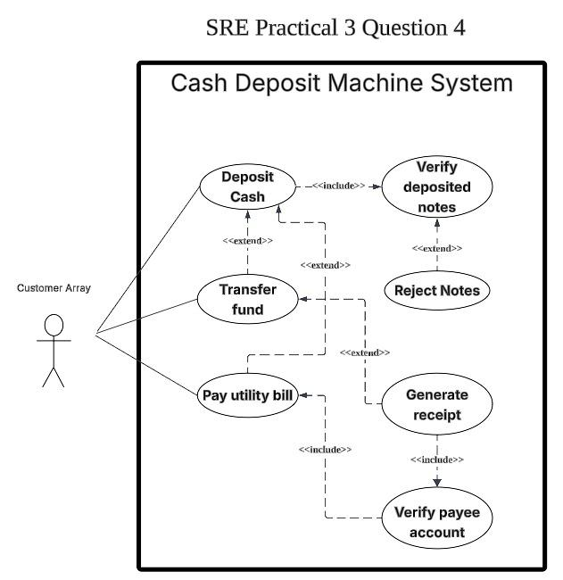
Analyze the above scenario and construct a use case diagram that depicts the functional requirements for the cash deposit machine. You are required to add <<include>> or <<extend>> relationship in your diagram.
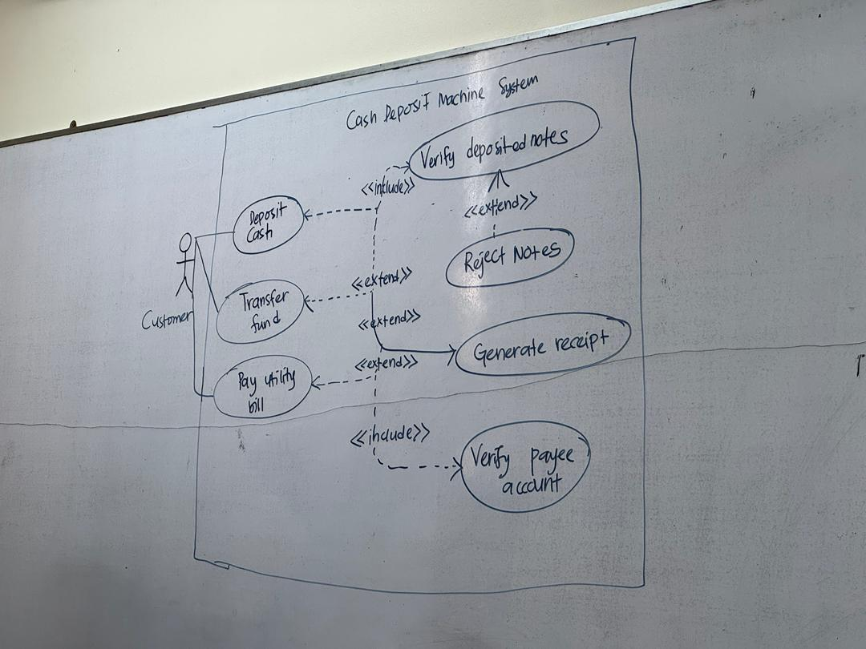
- The customer is allowed to place bus tickets reservation based on the bus schedule availability via online. If the bus schedule is available, the system will check the seat availability. If the seat is available, the system will request customer’s personal details. The system will check the customer’s status. If he or she is a new customer, the system will register the customer details into the system; else the customer can proceed to make the reservation.

Once the reservation transaction is done, the system will display the total amount payable and the customer should make online payment one day before the departure date and time; else the system will automatically cancel the reservation. Once the payment transaction is done, the system should be able to generate the online ticket receipt and the customer is required to print out the receipt as a proof.

Based on the case given above, construct a suitable use case diagram for the Online Bus Tickets Reservation System. Your use case diagram should include the following system functionalities:

- Register new customer
- Reserve bus tickets
- Cancel reserved tickets
- Make online payment
- Generate online ticket receipt
- Check the availability of schedule
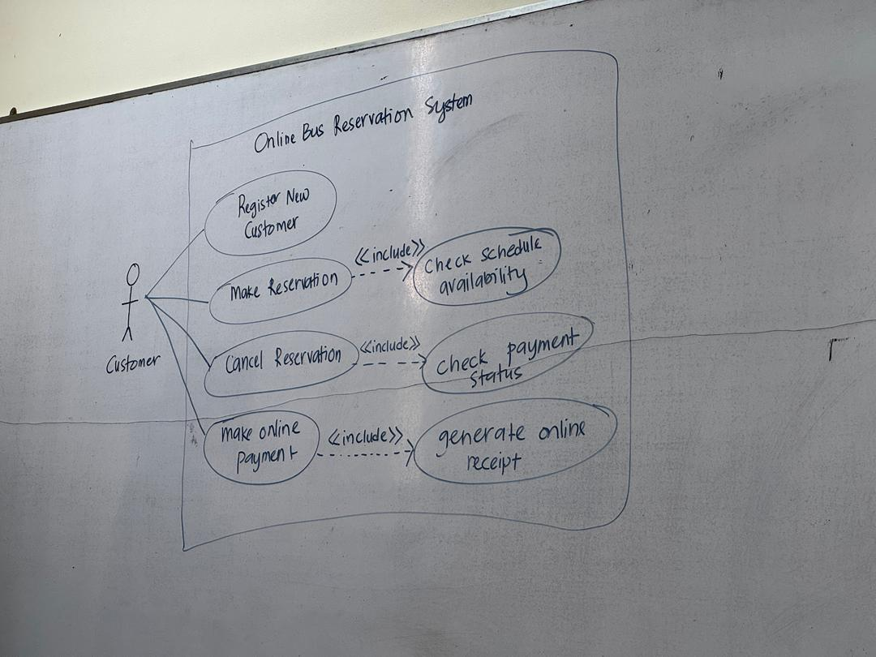
- Check payment status

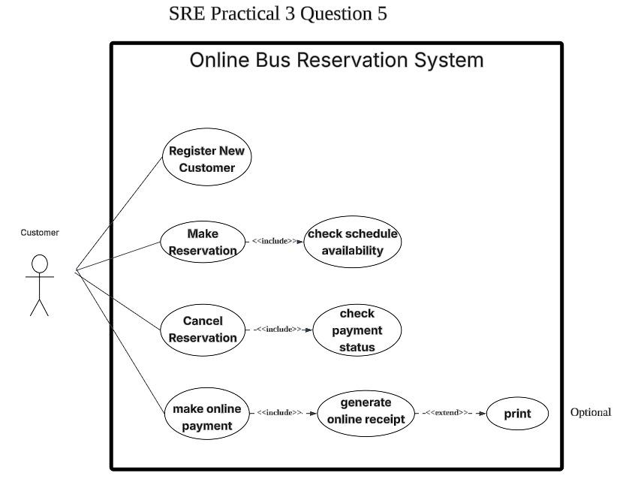
- Construct an analysis class diagram based on the following description:

A customer can track the parcel location via online by entering the shipment code. There are two types of customers: individual customer and corporate customer. The shipment details such as shipment code, shipment date, shipment status and etc. will be stored in the system. The customer is allowed to claim compensation for damaged items.

The analysis class diagram should include entity classes with appropriate attributes, association, generalization and multiplicity of the associations.
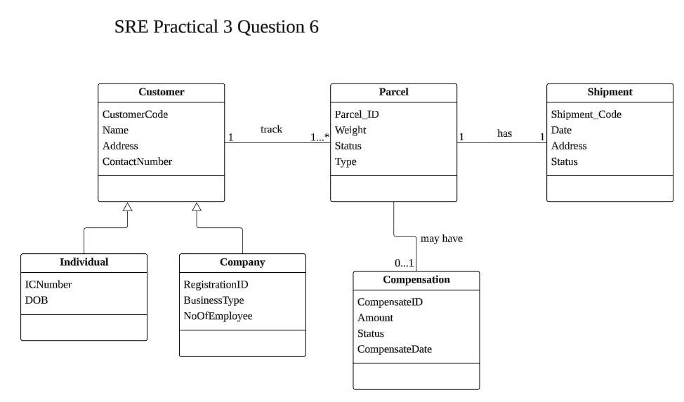

- Construct a relevant UML Class diagram to show aggregation or/and composition for the following:

An email inbox has many incoming emails daily. Each email has a header, a body and optionally it may consist of one or many attachment files.

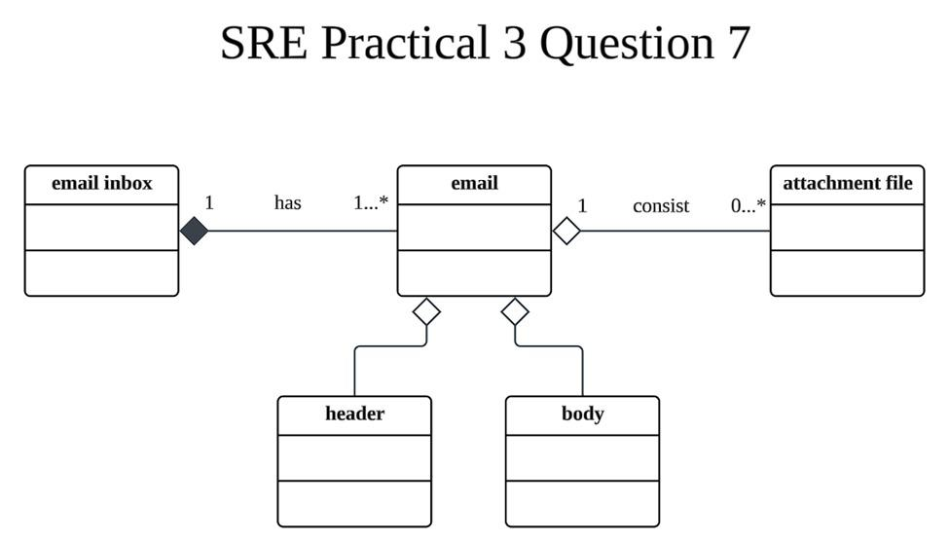

- The examination center of ABC College releases the students’ results at the end of each semester.

The students can proceed to the next semester if they pass all the subjects for that semester and the student’s status is “normal”. If the students fail 2 or more subjects, they cannot proceed to the next semester and the student’s status is “repeat”. However, if students failed only 1 subject, they can take the special examination that will be held 2 weeks time after the results are released and the student’s status is “resit”. Finally, if the students did not pay the school fees for that semester, they will automatically be withdrawn from their programme.

Based on the scenario described, draw a state chart diagram for the Student class. Your state chart diagram should include relevant states, events, guard conditions and show the state transitions.

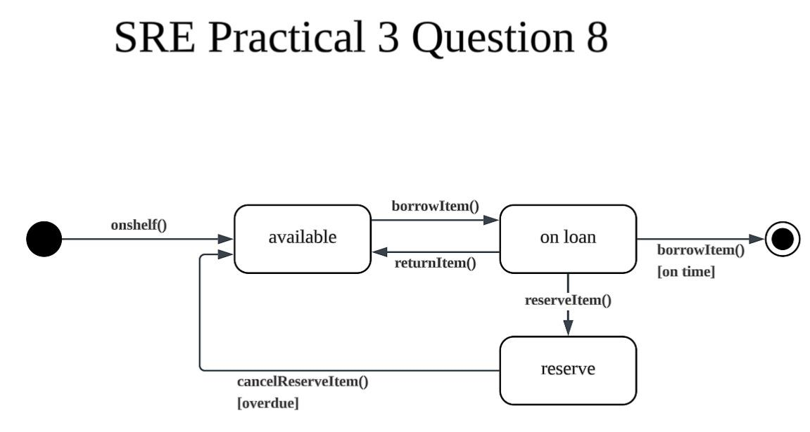
- Draw a state chart diagram for a Book class based on the following description:

A book is available on the shelf in library. When a member borrows a book, the book’s state is on loan. Members can reserve books that are on loan. When the book is returned on time, the member who reserved the item can then borrow it.

Your state chart diagram should include relevant states, events, guard conditions and show the state transitions.

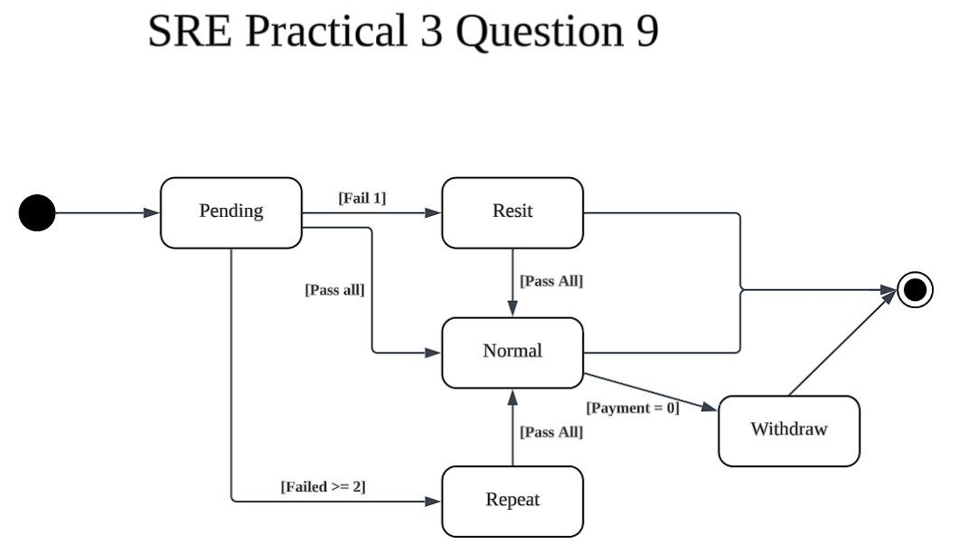

10. Assume that you, as a project manager, are considering to adopt either Viewpoint-Oriented Analysis method or Object-Oriented Analysis method in requirements gathering and analysis for a project.

- Describe Viewpoint-Oriented Analysis in the requirement analysis process.

- Evaluate the use of Viewpoint-Oriented Analysis method in requirements gathering and analysis.

- Discuss the main tasks involved in Object-Oriented Analysis.

- Suggest and briefly explain 2 approaches to identify objects and classify of objects.

